CSIT314 Software Development Methodologies - Group Project

Sprint 2 - US18: Search company information
Interior Design Platform - Interior Designer
All diagrams were drawn in draw.io. Open "US18 Search company information.drawio" in this folder to edit them - each diagram is its own page in that file. The exported images are in the "diagrams" folder.

Assumptions
- The system is the Interior Design Platform from the project specification. Sprint 2 covers the Interior Designer's log in, company profile and log out stories (US13 - US19) and the Platform Manager's log in, log out and IDP category stories (US39 - US45).
- We follow B-C-E: the actor only talks to the boundary (page), the boundary only talks to the controller, and the controller works with the entity classes. There is one controller per use case.
- The boundary checks all the input (required fields, lengths, formats, e.g. not suspending your own profile) and trims spaces, then passes an entity object on. The controller just calls the entity and returns the result. The entity checks for duplicates and the database state (e.g. name already used, only Active rows are changed), then saves. In US18 the page trims the keyword, SearchCompanyInformationController only calls the entity, and the entity reads the owner's Active row and works out which fields match.
- Each designer has one company profile, so US18 searches the fields inside the designer's own company profile. It doesn't search other designers' companies.
- The six fields searched are, in this order: companyName, description, services, email, phone and address. The page shows them with its own labels (FIELD_LABELS): Company name, Company description, Services offered, Contact email, Contact phone and Company address.
- A field matches if the keyword is part of its field name (e.g. "phone") or its saved value (e.g. "renov"). Capitals are ignored and the page removes the spaces at the start and end. Characters like % are searched as normal text.
- An empty keyword, or clicking "Clear", shows all six fields. Empty optional fields show "Not provided" (this is display text, it isn't searched).
- The entity returns the CompanyProfile with a matchedFields list (the names of the matching fields). An empty list means nothing matched.
- If the designer has no Active company profile (never created, or deleted with US17), the entity returns None and the page shows "You have not created a company profile yet" (HTTP 404). There is no separate "has a profile?" call before the search.
- Searching is read-only - it never changes the company profile. The owner always comes from the logged-in session, so a designerId or companyId put in the URL is ignored. IDs, the created date and the designer's account details are never searched or shown.
- Logged in as an interior designer (UC13) is the precondition. designerLoginRequired in app.py only sends someone with no session to /designer/login; the use case doesn't check the designer again.

1. User story
Story ID | US18
User story | As an interior designer, I want to search my company's information so that I can find the details I need.
Actor | Interior Designer
Priority | Medium
Story points (estimate) | 2
Acceptance criteria | 1. Given I am viewing my company profile, there is a "Search company information" button.  2. Given I type a keyword and click "Search", then I see the fields whose name or saved information contains the keyword (not case sensitive), in a Field / Information table.  3. Given the keyword is empty, or I click "Clear", then I see all six fields.  4. Given nothing matches, then I see "No matching company information found" and my keyword stays in the box.  5. Given I have no company profile, then I see "You have not created a company profile yet".  6. Searching never changes my company profile.
Tasks | T18.1 Write the use case description and draw the use case diagram  T18.2 Draw the B-C-E class diagram and the sequence diagram  T18.3 Draw the wireframes for the search button, the results, no matches, all information and profile not found  T18.4 Write the unit tests first (TDD) for CompanyProfile.searchCompanyInformation(), SearchCompanyInformationController and SearchCompanyInformationPage  T18.5 Code CompanyProfile.searchCompanyInformation(designerId, keyword): None without an Active profile, otherwise the CompanyProfile with matchedFields (field name or value, not case sensitive)  T18.6 Code SearchCompanyInformationController.searchCompanyInformation(designerId, keyword): one call to the entity  T18.7 Code SearchCompanyInformationPage (trim, FIELD_LABELS, the three results), the search template and the button on the view page  T18.8 Run the test cases, fix bugs and push to the repo so the CI pipeline runs the unit tests

2. Use case diagram
The user story becomes one use case, UC18 Search company information. The Interior Designer is the only actor.
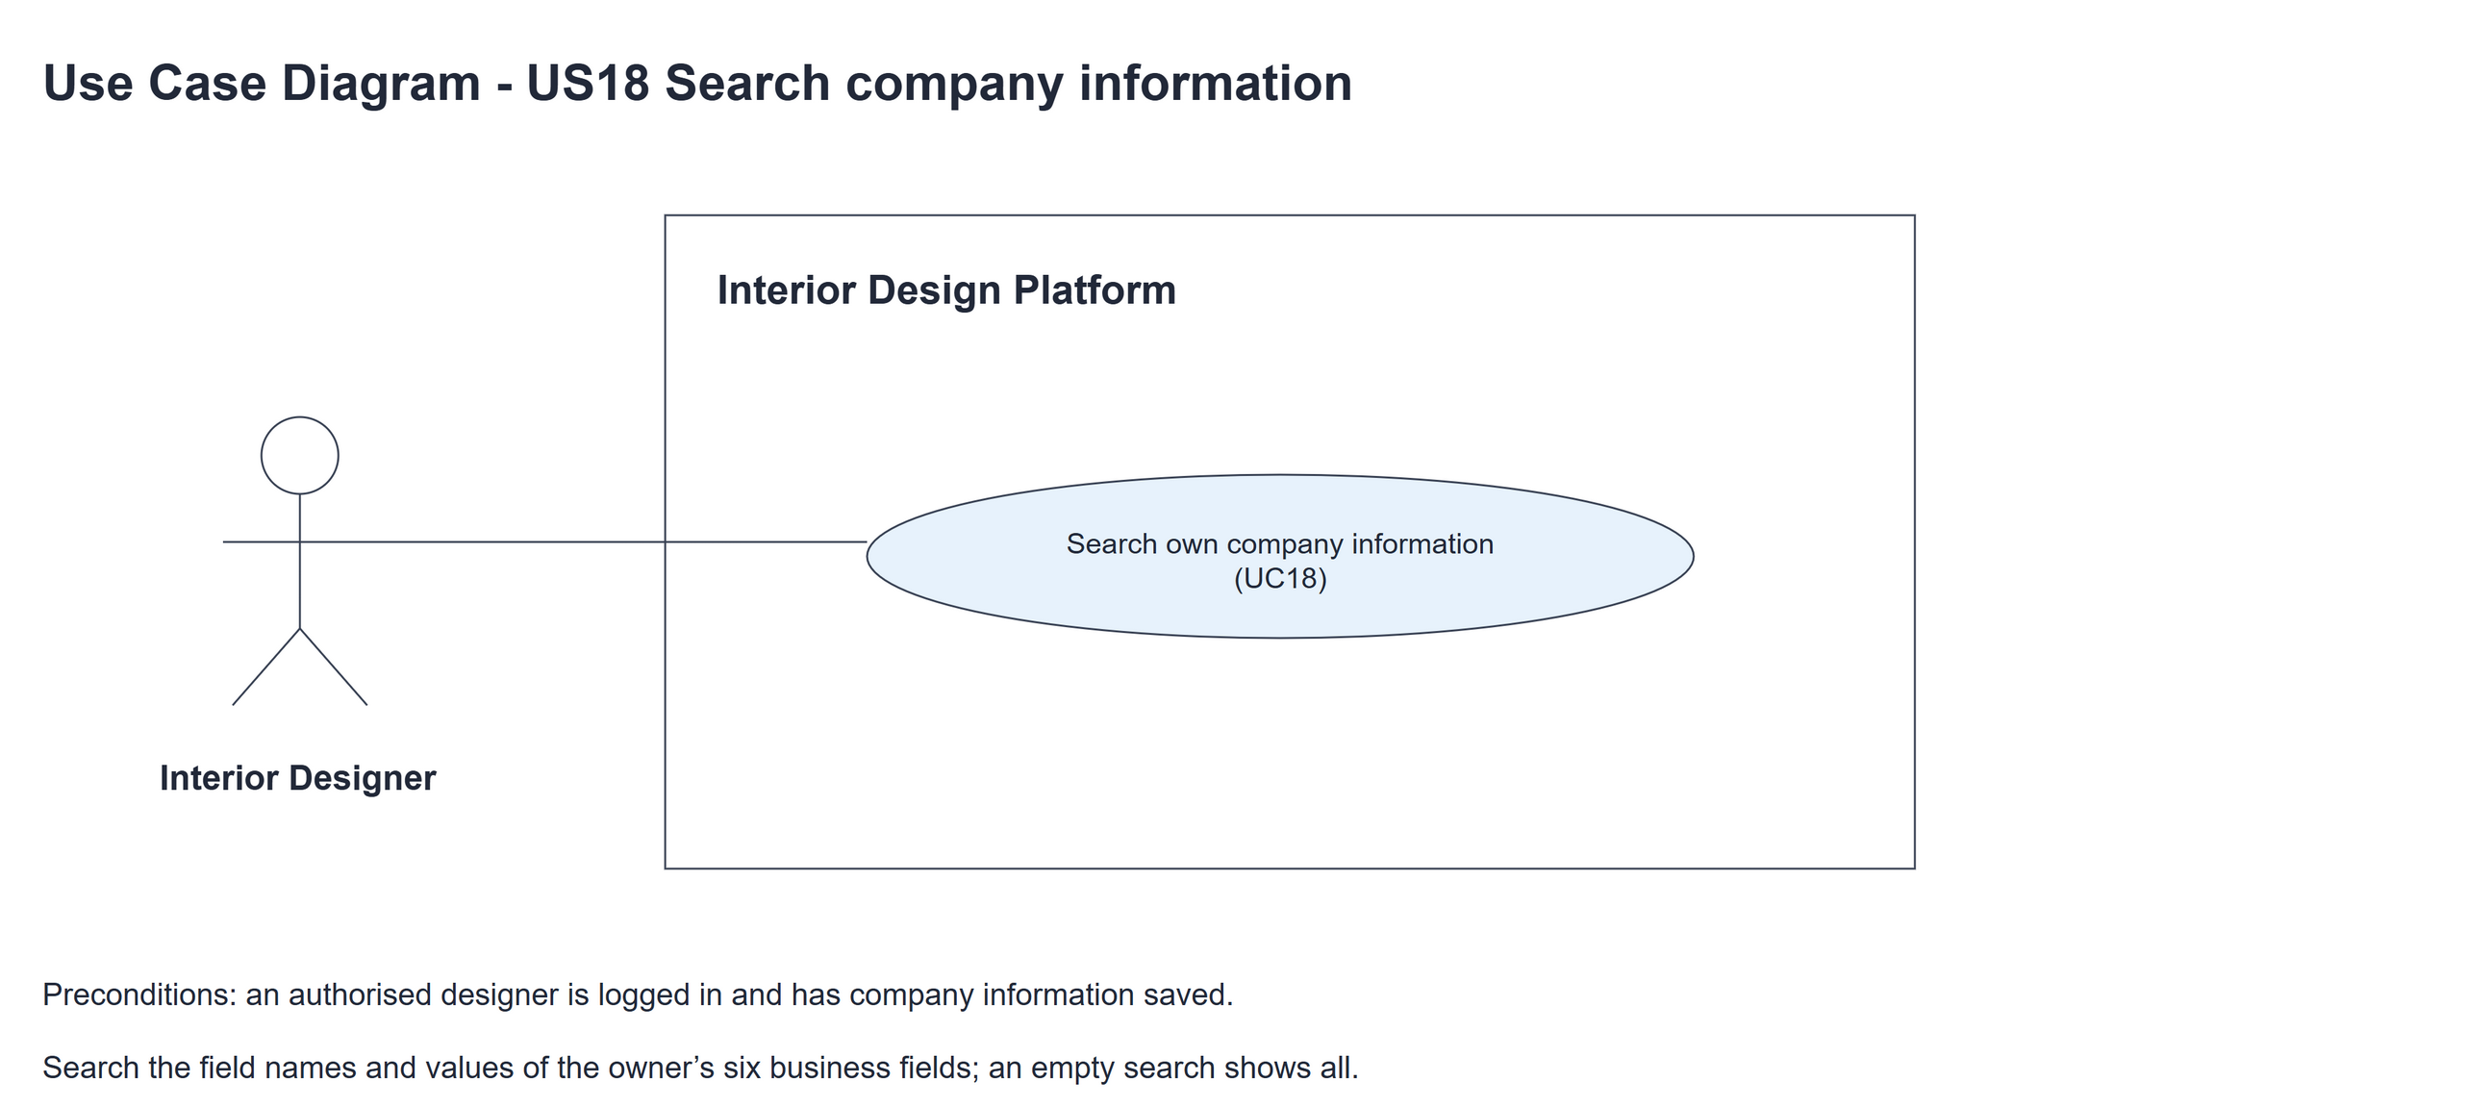
Figure 1: Use case diagram for US18 Search company information

3. Use case description
Use case | UC18 Search company information
Actor | Interior Designer
Brief description | The Interior Designer searches the information in their company profile to find the details they need.
User story | US18: As an interior designer, I want to search my company's information so that I can find the details I need.
Preconditions | The Interior Designer is logged in (UC13). designerLoginRequired in app.py only sends someone with no session to /designer/login.  The designer has an Active company profile (UC14).
Trigger | The Interior Designer clicks "Search company information" on the company profile page (UC15).
Basic flow | 1. The Interior Designer clicks "Search company information", or types a keyword and clicks "Search".  2. The system removes the spaces from the start and end of the keyword.  3. The system looks in the designer's Active company profile for the fields whose name or saved value contains the keyword (not case sensitive; an empty keyword matches all six).  4. The system shows the matching fields with their labels in a Field / Information table and keeps the keyword in the box.
Alternative flows | 3a. The designer has no Active company profile: the system shows "You have not created a company profile yet" (HTTP 404) with a create link. The use case ends.  3b. The keyword is empty, or the Interior Designer clicks "Clear": the system shows all six fields.  4a. Nothing matches: the system shows "No matching company information found" and keeps the keyword. The designer can search again (step 1).
Postconditions | The matching company information is shown. Nothing in the database is changed.

4. Wireframes
The wireframes were drawn in draw.io. They are low-fidelity: they show the layout and the flow, not the final colours. The orange numbers match the notes under each screen.

4a - Search button
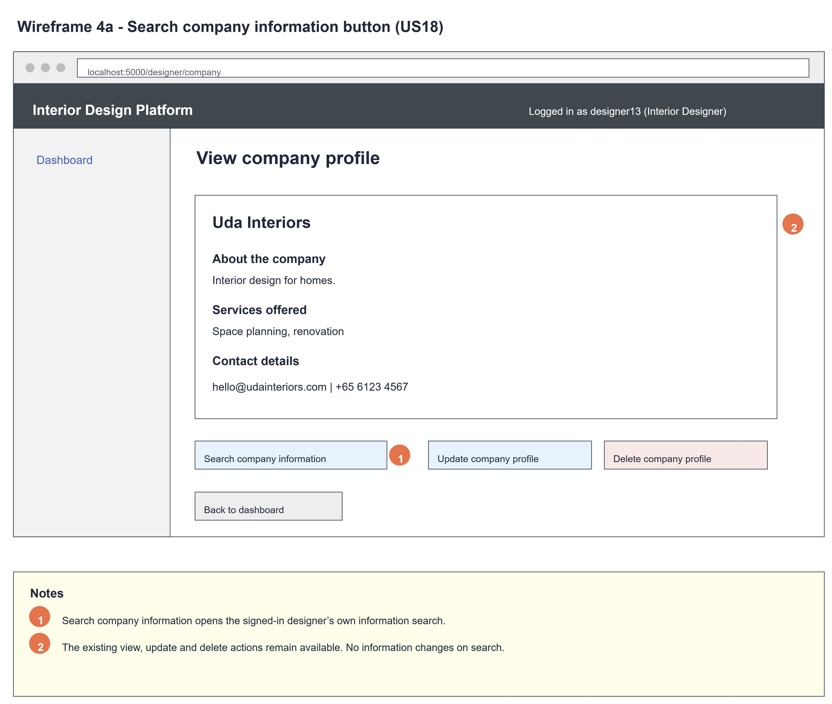
Figure 2: Wireframe 4a - Search button (US18)

4b - Search results
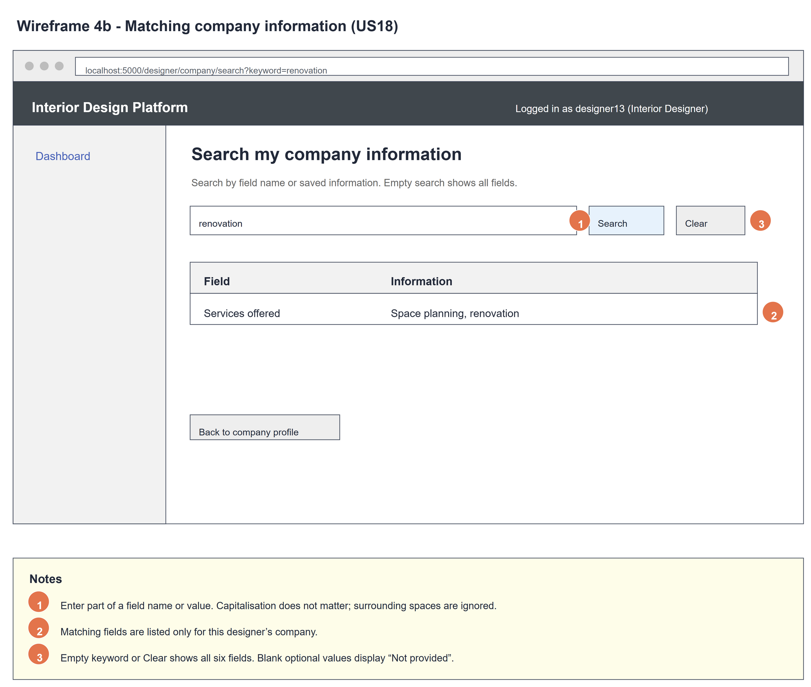
Figure 3: Wireframe 4b - Search results (US18)

4c - No matching information
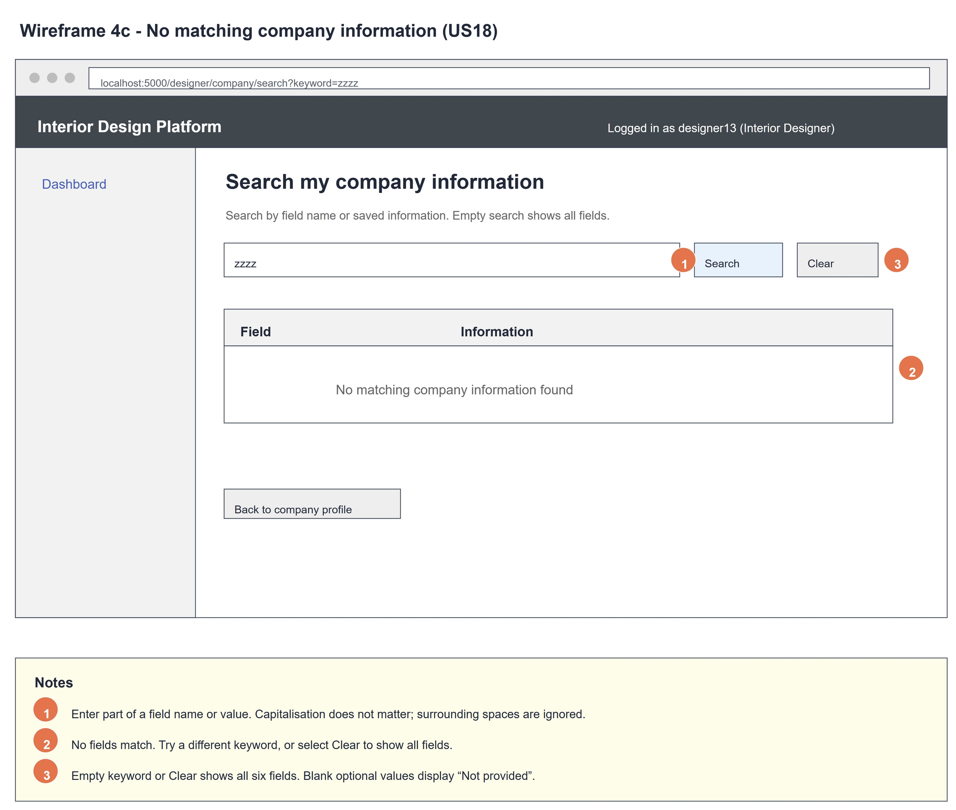
Figure 4: Wireframe 4c - No matching information (US18)

4d - All information
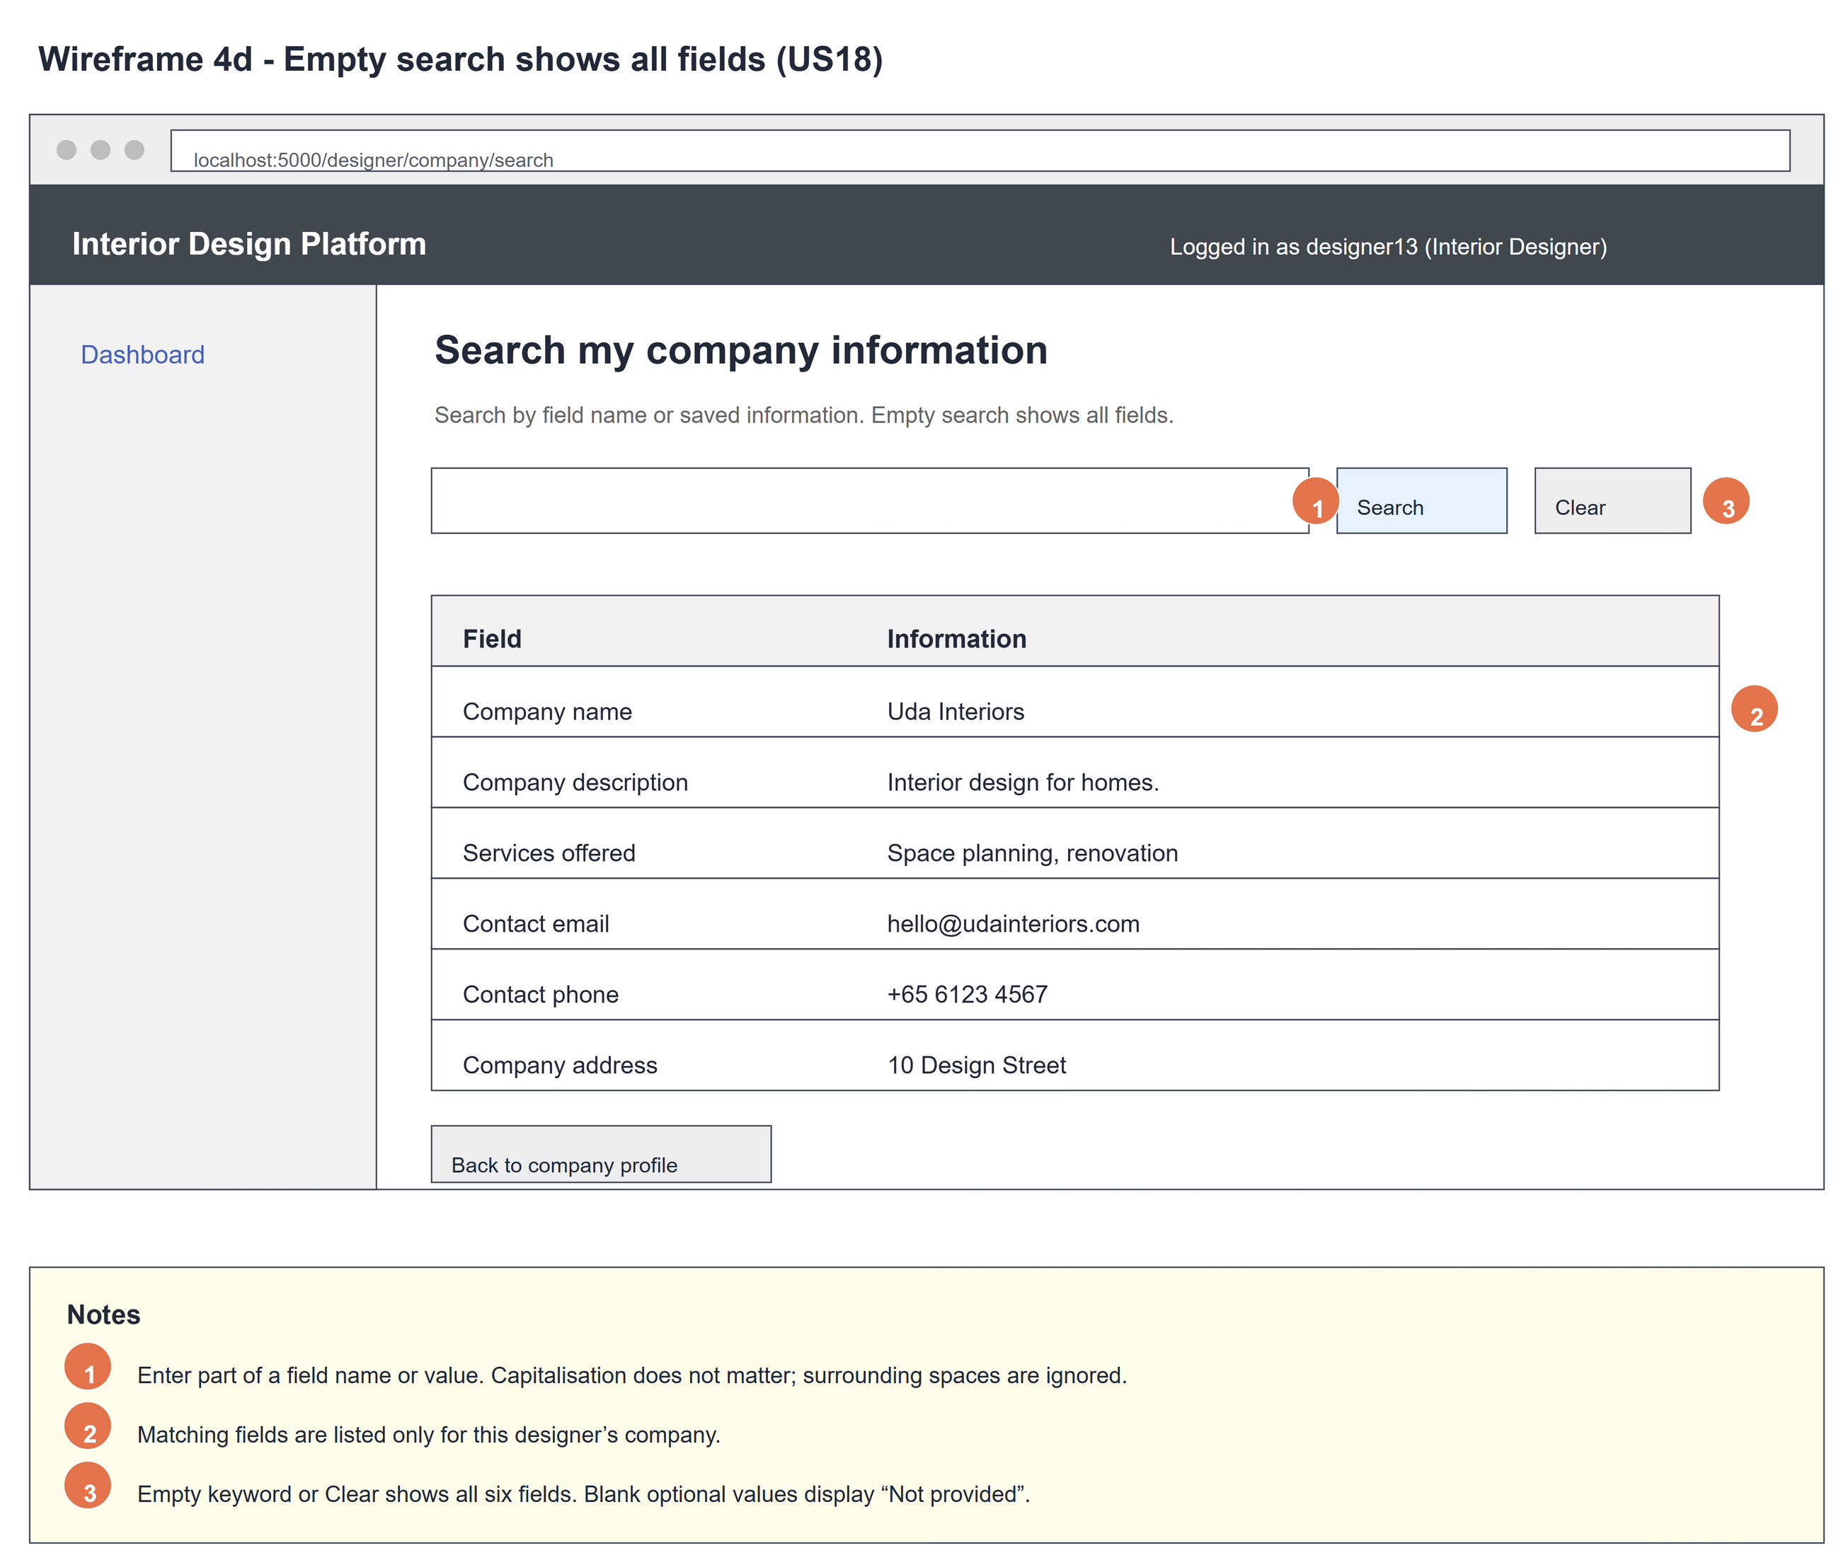
Figure 5: Wireframe 4d - All information (US18)

4e - Profile not found
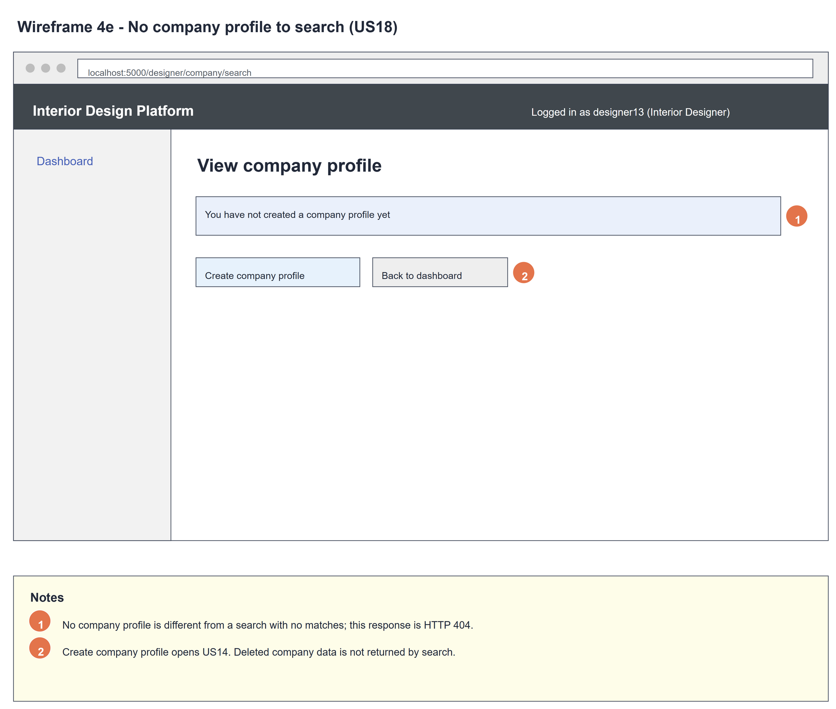
Figure 6: Wireframe 4e - Profile not found (US18)

5. B-C-E class diagram
The solid line means the boundary calls the controller. The dashed line means the controller uses the entity class. Only the operations needed for this use case are shown.
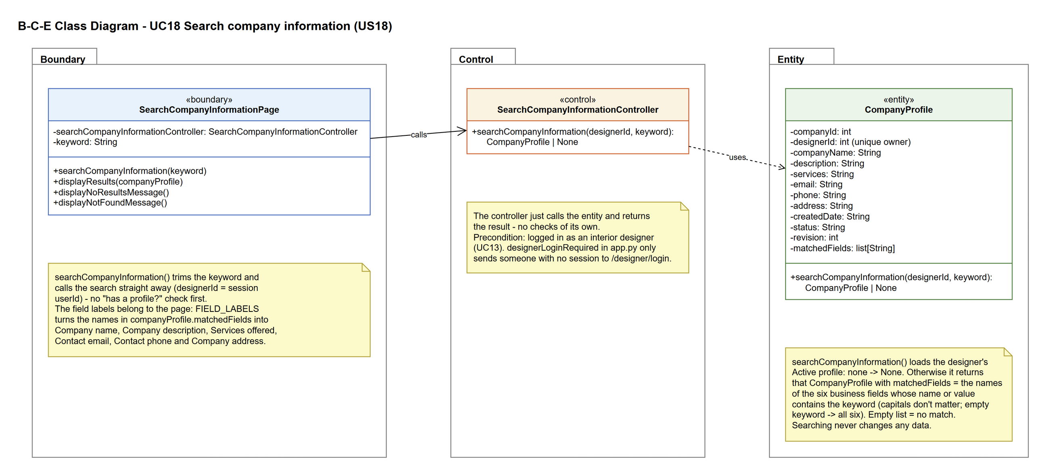
Figure 7: B-C-E class diagram for US18 Search company information
Layer | Class | What it does
Boundary | SearchCompanyInformationPage | The search page. searchCompanyInformation(keyword) trims the keyword, takes the owner from the session and calls the controller straight away. It shows the not-found page (displayNotFoundMessage) if the result is None, the no-match message (displayNoResultsMessage) if matchedFields is empty, otherwise displayResults(companyProfile). The field labels (FIELD_LABELS) belong to the page.
Control | SearchCompanyInformationController | Controller for UC18. searchCompanyInformation(designerId, keyword) just calls the entity and returns the result - no checks and no trimming.
Entity | CompanyProfile | searchCompanyInformation(designerId, keyword) reads only this owner's Active profile. It returns None if there isn't one, otherwise the CompanyProfile with matchedFields = the names of the fields whose name or value contains the keyword, in the fixed order (empty = no match).

6. Sequence diagram
The sequence diagram follows UC18. The page trims the keyword and takes the designer from the session (steps 1-2), then calls the search straight away - there is no separate "has a profile?" check. The controller makes one call to CompanyProfile.searchCompanyInformation(), which returns None when there is no Active profile, or the CompanyProfile with matchedFields (step 3). The three-way alt shows the not-found page (alternative flow 3a), the no-match message (alternative flow 4a) or the matching fields with their labels from FIELD_LABELS (step 4).
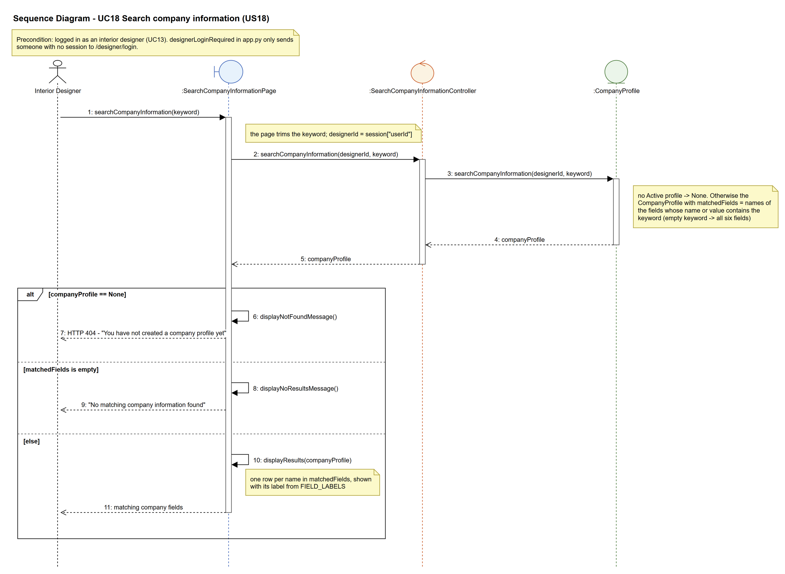
Figure 8: Sequence diagram for UC18 Search company information

7. Test cases
Test data used below (same as database/seedData.py and the test files): user profiles User Admin (id 1), Interior Designer (id 2), Customer (id 3) and Platform Manager (id 4), all Active. User accounts admin01 / Admin@123 (User Admin) and cust001 / Cust@123 (Customer). The designer account designer13 / Design@123 (Tengku Uda Designer, Interior Designer profile) is made first with UC8. Company data: Uda Interiors, "Interior design for homes.", "Space planning, renovation", hello@udainteriors.com, +65 6123 4567, 10 Design Street. designer13 already has this company profile.

7a. System test cases (black box)
Equivalence partitioning and boundary value analysis were used to pick the test data. Fill in "Actual result" and "Pass/Fail" after running each test.
Test ID | Scenario | Prerequisites | Test steps | Test data | Expected result | Actual result | Pass / Fail
TC18.1 | Search by part of a value | Logged in as designer13. Has a company profile. | 1. Click "Search company information"  2. Type the keyword  3. Click "Search" | renovation | Only "Services offered - Space planning, renovation" is shown. The keyword stays in the box.
TC18.2 | Capitals are ignored | Logged in as designer13. Has a company profile. | 1. Type the keyword  2. Click "Search" | RENOVATION | Same result as TC18.1.
TC18.3 | Search by field name | Logged in as designer13. Has a company profile. | 1. Type the keyword  2. Click "Search" | phone | Only "Contact phone - +65 6123 4567" is shown.
TC18.4 | Empty keyword | Logged in as designer13. Has a company profile. | 1. Leave the box empty  2. Click "Search" | (empty) | All six fields are shown.
TC18.5 | Clear | TC18.1 done. | 1. Click "Clear" | - | The box is empty and all six fields are shown.
TC18.6 | No match | Logged in as designer13. Has a company profile. | 1. Type the keyword  2. Click "Search" | zzzz | "No matching company information found". The keyword zzzz stays in the box.
TC18.7 | Empty optional fields | Profile saved with no email, phone or address. | 1. Open the search page | (empty) | Contact email, phone and address show "Not provided".
TC18.8 | No company profile | Logged in as designer13. No company profile. | 1. Open /designer/company/search | - | "You have not created a company profile yet" (HTTP 404).
TC18.9 | Updated info is searchable | Services updated to "Office refurbishment" (UC16). | 1. Search for the keyword | refurb | "Services offered - Office refurbishment" is shown.
TC18.10 | Deleted profile | designer13's profile was deleted (UC17). | 1. Open /designer/company/search?keyword=Uda | Uda | "You have not created a company profile yet" (HTTP 404). The deleted details are not shown.
TC18.11 | Not logged in | Not logged in. | 1. Open /designer/company/search | - | Sent to the designer login page.

7b. Unit test cases (for TDD)
These are written before the code (test-driven development) and run automatically in the CI pipeline. They cover normal inputs, abnormal inputs and boundary values. Each one matches a test function in tests/test_us18_searchCompanyInformation.py (UT18.1 is test_ut18_1_...). "Pass" is from the pytest run on 9 November 2026.
Test ID | Class and method | Input / setup | Expected output | Type | Pass / Fail
UT18.1 | SearchCompanyInformationController.searchCompanyInformation() | designer13, "renov" | Returns the CompanyProfile with matchedFields == ["services"] | Normal | Pass
UT18.2 | SearchCompanyInformationController.searchCompanyInformation() | designer13, "RENOVATION" | matchedFields == ["services"] | Normal | Pass
UT18.3 | SearchCompanyInformationController.searchCompanyInformation() | designer13, "" | matchedFields has all six field names in order | Boundary | Pass
UT18.4 | SearchCompanyInformationController.searchCompanyInformation() | designer13, "zzzz" | Returns the CompanyProfile with matchedFields == [] (empty) | Abnormal | Pass
UT18.5 | SearchCompanyInformationPage.searchCompanyInformation() | GET keyword " renovation " | The page trims it: only Services offered is shown and the box shows "renovation" | Boundary | Pass
UT18.6 | SearchCompanyInformationPage.searchCompanyInformation() | GET keyword " " | The page trims it to "" and all six values are shown | Boundary | Pass
UT18.7 | SearchCompanyInformationController.searchCompanyInformation() | designer13, "phone" (a field name) | matchedFields == ["phone"]; the profile's phone is "+65 6123 4567" | Normal | Pass
UT18.9 | SearchCompanyInformationController.searchCompanyInformation() | designer13 with no profile, "" | Returns None | Abnormal | Pass
UT18.10 | CompanyProfile.searchCompanyInformation() | designer13, "hello@" | matchedFields == ["email"] | Normal | Pass
UT18.11 | CompanyProfile.searchCompanyInformation() | designer13, "Design Street" | matchedFields == ["address"] | Normal | Pass
UT18.12 | CompanyProfile.searchCompanyInformation() | designer18 (no profile), "Uda" | Returns None - designer13's company isn't searched | Abnormal | Pass
UT18.13 | CompanyProfile.searchCompanyInformation() | "%" before and after the description has "Save 20% on design" | matchedFields empty, then ["description"] | Boundary | Pass
UT18.14 | CompanyProfile.searchCompanyInformation() | designer13, "design" | The company_profile table is unchanged | Normal | Pass
UT18.15 | CompanyProfile.searchCompanyInformation() | "designer13" and "Design@123" | matchedFields is empty for both (account details aren't searched) | Abnormal | Pass
UT18.16 | SearchCompanyInformationPage.displayResults() | GET ?keyword=renovation | "Services offered" and its value shown, email not shown, keyword kept | Normal | Pass
UT18.17 | SearchCompanyInformationPage.displayNoResultsMessage() | GET ?keyword=zzzz | "No matching company information found", keyword kept | Abnormal | Pass
UT18.18 | SearchCompanyInformationPage.searchCompanyInformation() | GET with no keyword | All six saved values shown | Boundary | Pass
UT18.19 | designerLoginRequired (app.py) | GET /designer/company/search, not logged in | Redirects to /designer/login | Abnormal | Pass
UT18.21 | SearchCompanyInformationPage.displayNotFoundMessage() | designer13 with no profile | HTTP 404, "You have not created a company profile yet" and a create link | Abnormal | Pass
UT18.22 | SearchCompanyInformationPage.searchCompanyInformation() | URL includes designer18's designerId | No match; designer18's service not shown | Abnormal | Pass
UT18.23 | SearchCompanyInformationPage.displayResults() | email, phone and address empty | "Not provided" shown 3 times | Boundary | Pass
UT18.24 | SearchCompanyInformationPage.displayResults() | keyword "<script>" and a saved "<script>" description | Both shown escaped, not run | Abnormal | Pass
UT18.25 | SearchCompanyInformationPage.searchCompanyInformation() | Two searches | The company_profile table is unchanged | Normal | Pass
UT18.27 | View company profile page (UC15) | designer13 with a profile | Has the "Search company information" link | Normal | Pass
UT18.28 | Search after update and delete | Update services, search, delete (the confirmation posts companyId + revision), search again | Found after the update; HTTP 404 after the delete | Normal | Pass
UT18.29 | SearchCompanyInformationPage.searchCompanyInformation() and CompanyProfile.searchCompanyInformation() | designer13's profile deleted with suspendCompanyProfile(designerId, companyId, expectedRevision) (test_ut18_suspendedProfile_isUnavailable) | The page gives HTTP 404 and the entity returns None | Abnormal | Pass

